Andrew Mueller
ECE 497 Embedded Linux
Homework 7

The point of this homework assignment was to compare the speeds of different methods of copying GPIO copying. I used Python, C, and kernel modules. The results can be seen below. With an input of a 1kHz square waze.

 | Avg. Speed | Min speed | Max speed | CPU usage
Python | 195 us | 190 us* | 205 us* | 15%
C | 395 ns | 380 ns | 417 ns | 100%
Kernel Module | 300 ns | 293 ns | 305 ns | 95%
* - Assuming pulse was not missed

The Kernel Module ended being the fastest method while also having the least deviation. The C program used all of the CPU because it was contently pulling attempting to get high speeds. The python program would every so often miss a pulse. I think this is because the program was interrupt driven so if the program wasn’t running when the pulse happened then it would miss the edge change.
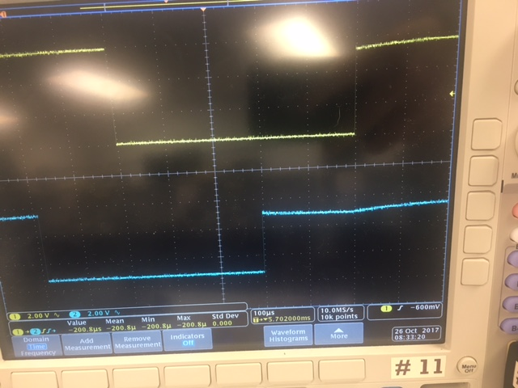

Above it can be seen the scope plot for the delay in the kernel module.

